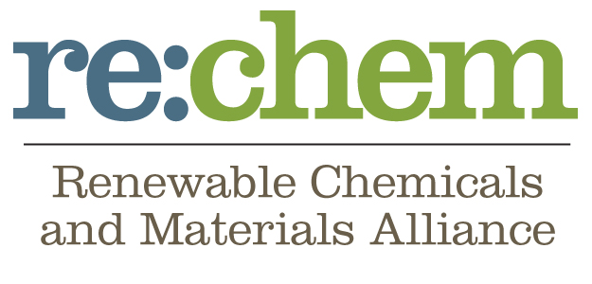

Contact Michele Jalbert
202.423.3106
mjalbert@corinneyoungllc.com
re:chem™

New US Farm bill hailed by Renewable chemical leaders

Key provisions championed by re:chem™ will enable rapid job growth

Washington, DC, January 27, 2014 – Leaders of the renewable chemicals and advanced materials industry – companies making widely used chemicals and everyday materials from renewable feedstocks, rather than oil – applaud key sections of this week’s anticipated new Farm Bill. The conference agreement includes loan guarantees, research and development opportunities and access to government purchasing programs.

“The inclusion of key provisions in the final Farm Bill helps the country improve its global manufacturing competitiveness, and speed to market higher performing products such as latex-based athletic gear and medical devices, cold water detergents, high strength composites for wind turbines, compostable cups and flatware, recyclable biobased carpets, and even polymers and fibers for emerging applications in light weighting cars and 3D printing,” said Corinne Young, Chief Advocate for re:chem™, the Renewable Chemicals and Advanced Materials Alliance, a group that has worked to support this noteworthy legislation. “These incentives will assist the renewable chemicals sector in taking root firmly here in the US. As the sector grows, innovation hubs and new value chains will develop – creating jobs to meet the growing global demand for better products produced more sustainably. I applaud the bipartisan leadership of Senators Stabenow and Cochran and Congressmen Lucas and Peterson in shepherding these critical programs.”

The renewable chemicals and advanced materials industry offers biobased, sustainable alternatives to petroleum based chemicals, plastics, polymers, emollients, cleaning agents, personal care items, fibers and a wide range of other everyday products. Key provisions of the Farm Bill will help companies in the industry bring their products to market in the US, ensuring that innovative technology is not only developed but also scaled here. This successful deployment will encourage further sector innovation and investment, in turn driving economic activity and jobs.

According to Marc Verbruggen, CEO of Minnesota-based Natureworks, one of the world’s largest biopolymer companies, “this Farm Bill represents an important step toward robust commercialization in the US, recognizing the innovative potential of biobased products in the new economy, defined by sustainable manufacturing and novel applications. We are grateful to astute policymakers, particularly Minnesota Senators Klobuchar and Franken, and Congressmen Peterson and Walz, who championed these critical provisions.”

Among the Farm Bill policy changes was the expansion of the Biorefinery Assistance Program. With these amendments, companies seeking to produce high-performance renewable chemicals and biobased products in the US are eligible for loan guarantees to build manufacturing plants.

“Access to these loan guarantees is significant in accelerating investment and creating new jobs in the US,” said K’Lynne Johnson, Elevance CEO in Illinois, “and these are high-value jobs, reflecting the technology advances and innovation that underpin the renewable chemical sector. Timely access to a loan guarantee accelerates moving forward at our Natchez, MS site. In particular, I would like to thank Senator Cochran and Congressman Harper for their leadership on the Farm Bill, as well as Senator Durbin and the Illinois delegation.”

A separate Farm Bill provision would encourage the joint USDA/DOE Biomass Research and Development Initiative to support continued successful biobased chemicals development.

Christophe Schilling, CEO of Genomatica in California, said, “Today’s breakthrough agreement supports both research and commercialization. Research support allows companies to develop novel, economically competitive solutions, such as our first commercial process, which is for the production of a biobased version of the chemical 1,4-butanediol. Commercialization incentives make it easier to build plants that use these innovations and create jobs. I want to thank Congressman Peters for his leadership in driving vital portions of this bill.”

Finally, the Farm Bill strengthens the USDA BioPreferred® program which supports the increased use and purchase of biobased products.

“We commend US leadership in promoting high-paying sustainable jobs and value-added bioproducts that compete on performance and cost in global markets,” lauded Chris Olsen, VP of Government Affairs at Tate & Lyle, headquartered in Illinois.

According to Young, “The global renewable chemicals market is conservatively estimated to exceed $85 billion over the next five years, with a compounded annual growth rate of 7.7%. “With today’s developments, the US is better positioned to compete in that exciting global opportunity – to grow, build, make and sell here -- and create hundreds of thousands of new family-sustaining, career jobs in the process.”

The Renewable Chemicals and Materials Alliance (re:chem) is relentlessly focused on promoting the federal policy priorities that offer the greatest potential to catalyze growth here in the US, enabling US competitiveness, sustainable manufacturing, jobs and goods to improve our lives. Created in 2013, the re:chem™ founders include leading renewable chemical companies, which are EPA Presidential Green Chemistry Award winners. To learn more, visit www.corinneyoungllc.com/rechem.html

# # #

